INFORMATION AND COMMUNICATIONS TECHNOLOGY

**Paper 1**

Theory

**S.3 BOT 2 2024**

1 hours 30 Minutes

**INSTRUCTIONS TO CANDIDATES:**

*This paper consists of two items, attempt all are compulsory*

**ITEM 1**

Akello, a business woman who operates a supermarket in Uhuru bar, has recently acquired a brand new computer set, power cables, extension cable, Uninterruptible Power Supply (UPS) from BTC- Electronic shop situated in Panga- Alayu Ngetta. She is very happy due to the acquisition of this machine, she thinks the business management would be made so easy and this would also help improve the level of business. But she is left dumbfounded since she lacks the skills to connect this computer to a usable state and she has approached you as a computer student for assistance.

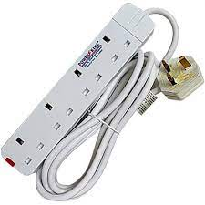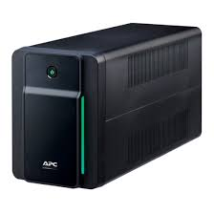

**Task**

1. Guide Akello on the necessary procedures for connecting the computer to a usable state.
2. What other devices can Akello add to help improve on her business

**Item 2**

Apio Mirriam a senior four student of BTC-Ngetta would like to go to her former school Itam P/S in Amolatar to get her PLE Result Slip since it is needed for UNEB registration. But due to heavy rain being experienced recently in the area, the route that lead to the school is heavily flooded and the school is hard to reach, she notices the slip can still be sent using the ICT technology and she has approached you to guide her on the steps she would use to get a copy of her results to help her in the registration.

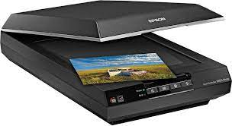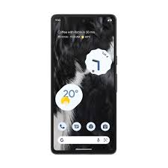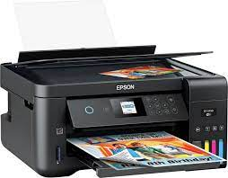

**Task**

1. Guide Apio on how she can get a copy of the document without physically going to Amolatar.
2. Explain to Apio reason why the devices used above always come along with user manual when they are bought.

***=END=***